Caritat Air Base

**Air Base 115 Orange-Caritat** ([French](http://en.wikipedia.org/wiki/French_language): *Base aérienne 115 Orange-Caritat "Capitaine de Seyne"*or *BA 115*, [IATA](http://en.wikipedia.org/wiki/International_Air_Transport_Association_airport_code):**XOG**, [ICAO](http://en.wikipedia.org/wiki/International_Civil_Aviation_Organization_airport_code): **LFMO**) is a small [French Air Force](http://en.wikipedia.org/wiki/French_Air_Force) base equipped with one runway and named after [Capitaine de Seyne](http://en.wikipedia.org/wiki/Capitaine_de_Seyne" \o "Capitaine de Seyne). It is located 5 kilometres (3 mi) east of[Orange](http://en.wikipedia.org/wiki/Orange,_Vaucluse), a [*commune*](http://en.wikipedia.org/wiki/Communes_of_the_Vaucluse_department) in the[Vaucluse](http://en.wikipedia.org/wiki/Vaucluse) department of the[Provence-Alpes-Côte d'Azur](http://en.wikipedia.org/wiki/Provence-Alpes-C%C3%B4te_d%27Azur)region in [France](http://en.wikipedia.org/wiki/France).

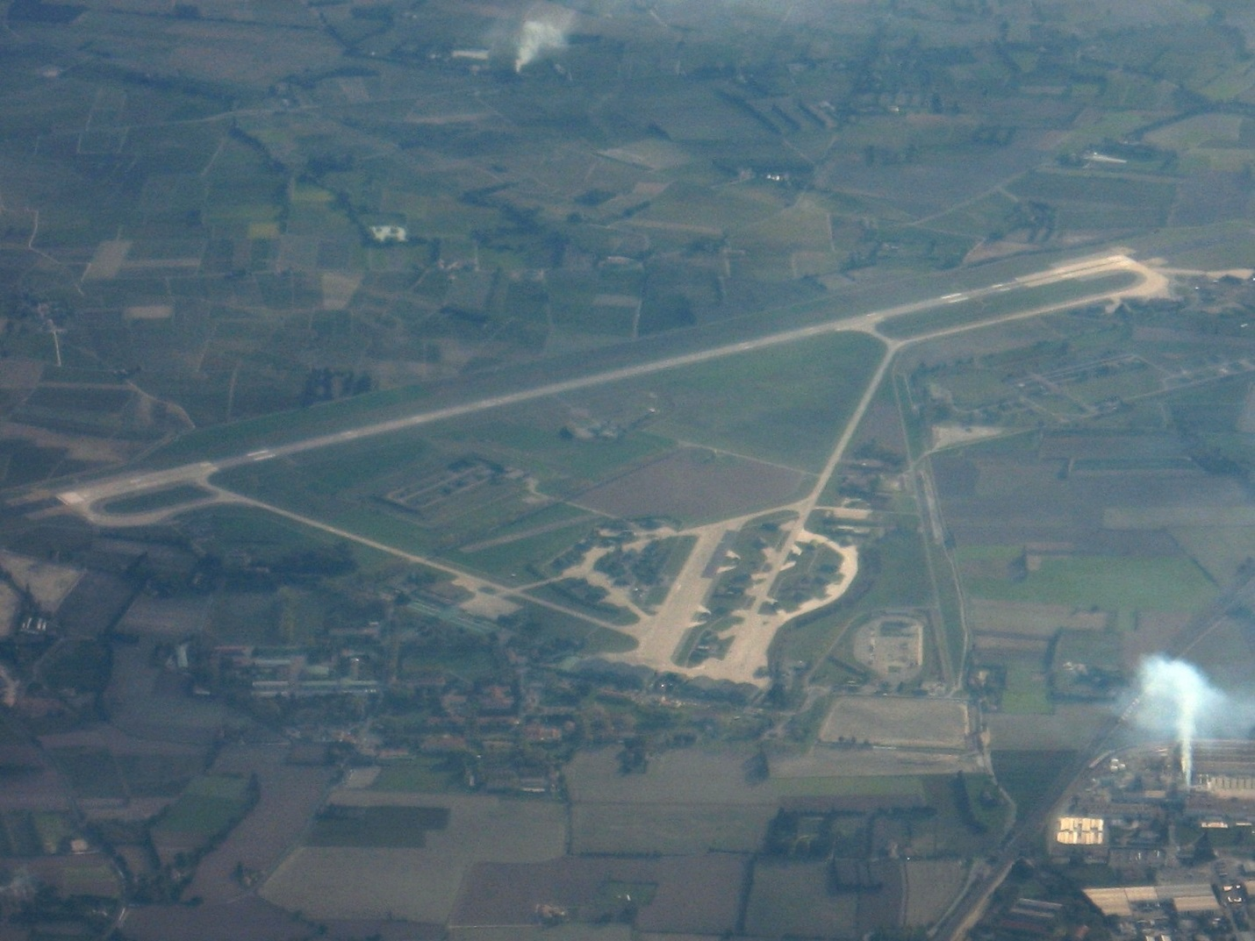

It hosts:

* 01.005 sqn Vendée (Fighter Squadron 01.005) and 02.005 sqn (02.005 Fighter Squadron) in France, equipped with the Dassault Mirage 2000 RDI and B / C type. The RDI to carry out all weather air defense missions, and the B / C types for pilot transition training and practical purposes.
* Filing a permanent workshop specialized ammunition (DAMS) detachment; this is a headquarters unit responsible for all Special Ammunition Storages in France.
* 10,950 sqn air defense (air defense squadron 10.950) the base air defense unit.
* Logistics establishment of the police Air Doors them -Valencia, a logistic unit.
* A guard detachment Fusiliers Commandos Air Responsible for ground-based defense and security

Source: [Wikipedia](http://en.wikipedia.org/wiki/Orange-Caritat_Air_Base)

Antique Theatre

**Architectural and prestigious place...**

Exceptional witness of the Antiquity, ranked as part of World heritage’s of UNESCO, the Antique Theatre of Orange is the most conserved in the whole of Europe. Edified in the beginning of the Christian Era, it owes its reputation to the remarquable conservation of its stage wall.  
It presents all the features of latin theatres according to "Vitruve" : the cavea (semicircle steps), lateral acces and the stage wall flanked by parascaenia.  
Built to accomodate the gallo-roman public, it was there that the Roman culture and language were diffused.  
9000 spectators could attend tragedies, comedies as well as dance shows, acrobatics and juggling.  
Columns and many statues in the niches decorated the stage wall, at the origins. Burned in the 4th century, the theatre lost its principal function. Its location, at the foot of the hill, makes it an element of the city’s defences. As time goes by, the theatre is invaded by houses and became a real inhabited area.

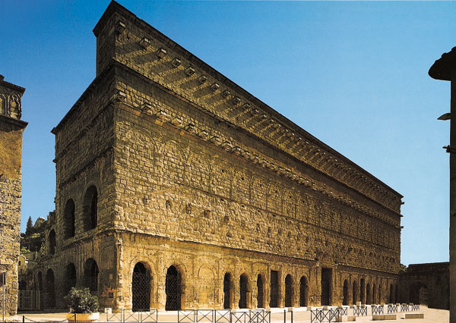

**...But also a place for the performing arts**

We have to wait the 19th century to rediscover the antique theatre as a place for the performing arts.  
Auguste Caristie, chief architect for the historical monuments, assures its restoration.  
Nowadays, the Theatre welcomes about ten thousand spectators on the occasion of various summer events, one of which are the Choregies.   
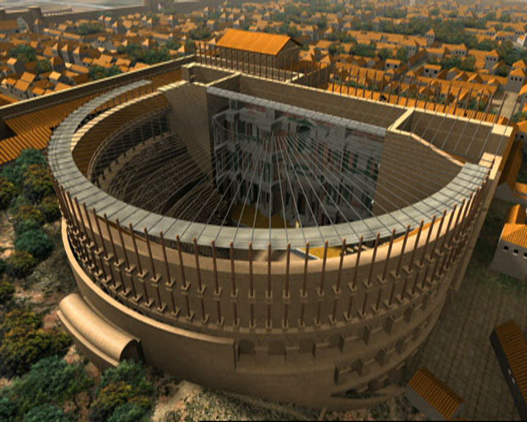  
**A glass-roof for a stone-theatre**

Since June 2006, the UNESCO’s classified monument is a world-wide exclusivity : it is not only the only antique theatre with a stage-roof but also, the unique theatre in the World with a well-conserved stage-wall.

Source: [Orange, Office de Tourisme](http://uk.otorange.fr/home/discover/monuments-museums-sites/antique-theater.aspx)

Parks & Gardens

For bird's-eye views of the theatre – and phenomenal vistas of Mont Ventoux and the Dentelles de Montmirail – follow montée Philbert de Chalons or montée Lambert up Colline St-Eutrope (St Eutrope Hill; elevation 97m), once the Romans' lookout point. En route, pass ruins of a 12th-century château , once the residence of the princes of Orange.  
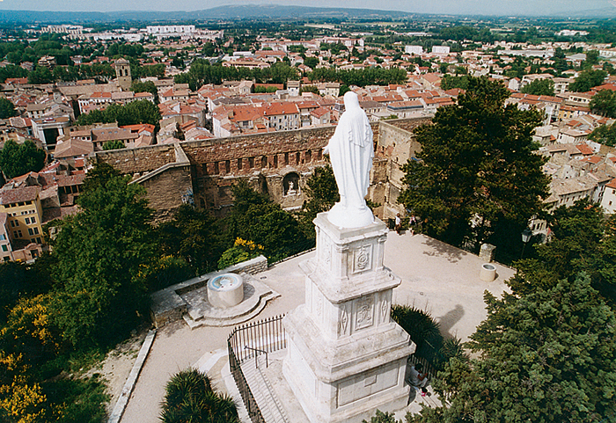  
Source: [Lonelyplaent](http://www.lonelyplanet.com/france/orange/sights/parks-gardens/colline-st-eutrope)

City of Orange

**ORANGE** was the former seat of the counts of Orange, a title created by Charlemagne in the eighth century and passed to the Dutch crown in the sixteenth century. The family's most famous member was Prince William, who ascended the English throne with his consort Mary in the 1688 "Glorious Revolution". Today the town is best known for its spectacular **Roman theatre**, which hosts the important summer Chorégies **music festival**. While the rest of the Orange is attractive enough, there's not a lot to detain you once you've visited the theatre and adjacent museum and taken a quick look at the Roman triumphal arch at the northern approach to the town centre. Unfortunately, the victory of Le Pen's Front National in the municipal elections of 1995, and again in 2001, has forced the May strip-cartoon festival, which brought in all kinds of weird and wonderful entertainment, to be abandoned.

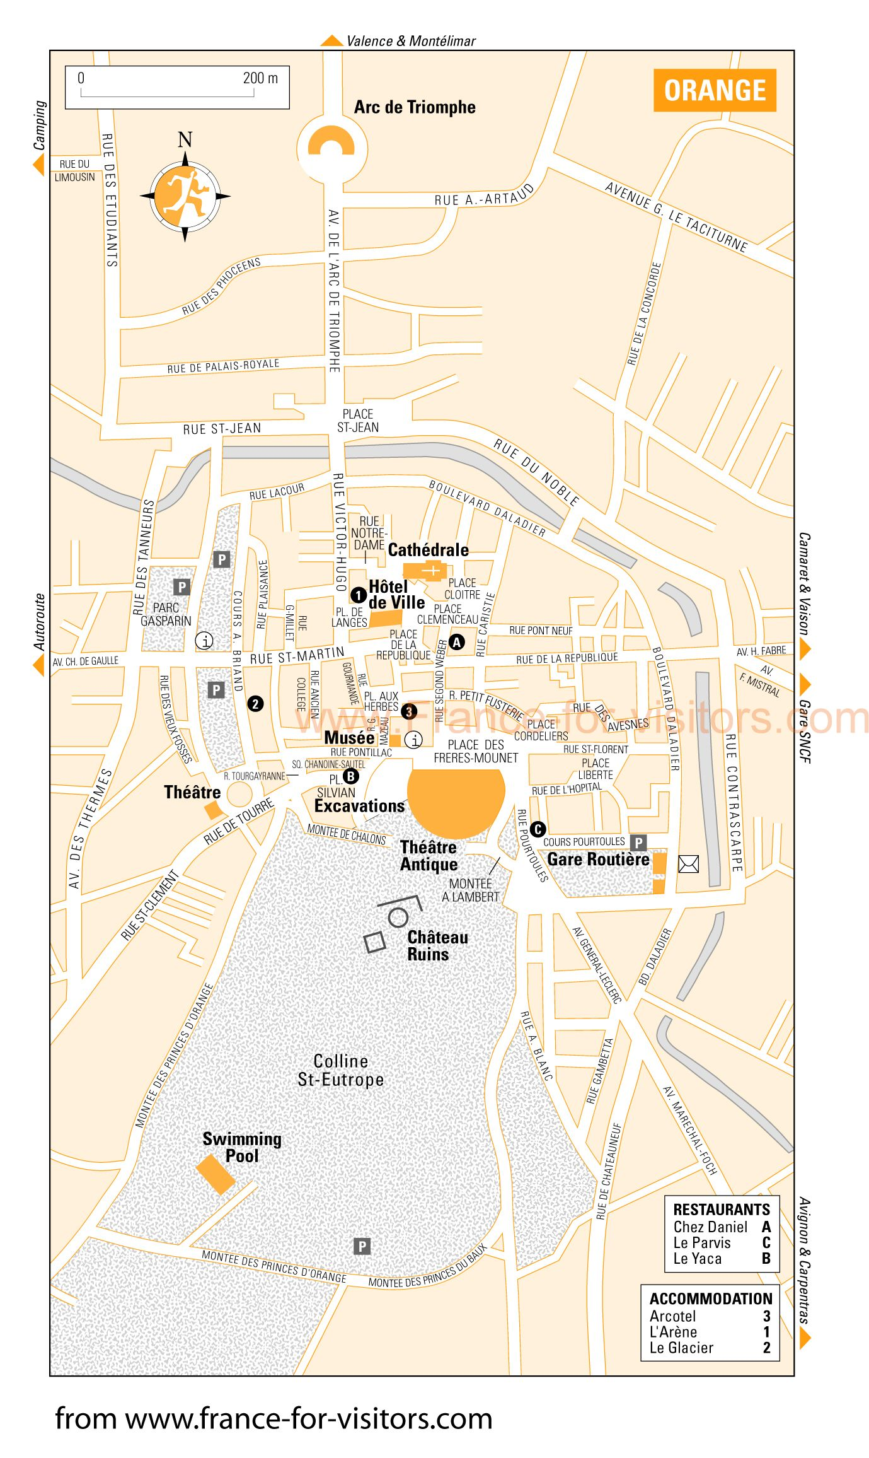

Source: [France for Visitors](http://france-for-visitors.com/france-maps/provence/orange-map-supersize.html)

An Outstanding “Terroir”

Video: <http://youtu.be/I10kbZSYY8Q?list=PLJXKwJn3bMOFoOS_bHhjMfaXqSLepqAsJ>